**Section> TAT Themes**

**SD :**

Factor – I (Planning and Organising)

**(a) Effective Intelligence :** wise, intelligent, meritorious,

**(b) Reasoning Ability :** I am acountable, can handle outside work, know imp of hardwork

**(c) Organising Ability :** manage intern, Potd, ssbprep, placement, follow routine. Organized person, prev exp of school

**(d) Power of Expression** : good com skills, gkd: regards me as best speaker, able to ckearly express

Factor – II (Social Adjustment)

**(e) Social Adaptability :** can make frnds easily, adapt to new envt, tools, languages

**(f) Co-operation :** good listeners to others soln, believe in teamwork, divide & conquer n*logn, help others

**(g) Sense of Responsibility :** responsible, have made best of opportunities provided. Have 2 offers & rejected multiple small ones. Doing 6mth intern, manage my own expenses & investing them

Factor – III (Social Effectiveness)

**(h) Initiative :** do work on my own, take parts in college CCA, serching for coys

**(i) Self Confidence:** have confidence in myself & skills. Confident that with my experience & pblm solving skills I can solve pblms

**(j) Speed of Decision :** I am quick at making decisions. Cover all aspects before making one

**(k) Ability to Influence the Group:** I am a group person, people listen to me as I maintain cheerful envt

**(l) Liveliness :** I am jovial & lively person with good humour

Factor – IV (Dynamic)

**(m) Determination :** I am determinant, 2000+ Lc que & 650+ days of streak of POTD

**(n) Courage :** I take risks when high chances of success, invest money in MF

**(o) Stamina:** I work 7+ hrs then do POTD, LC, upskill. I can handle stress

> Story in PPDT are general & u can make any story from it. For below story, hence to enhance qualitty of story, **think hard & solve a major pblm, do something for the society** eg for below story u can simply make that he visited his school or u can tackle the major pblm that u face in school that most studs are not able to choose their career based on their own choice. Made telegram communicty of his batch passouts & alumnis & gave guidance to teachers & studs. Bridged the gap btw industry & schools.

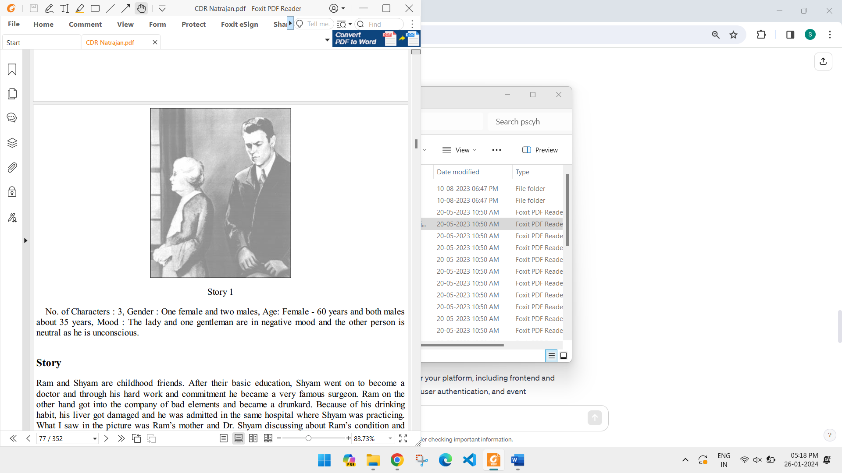

> In PPDT its all about perception. If u the story is a generalized one eg below, observe the clothings/hairstyle/ appearances/background of the character. Then relate where u have seen such characters in life : **below dicsussion reminds of a project lead briefing his team members**

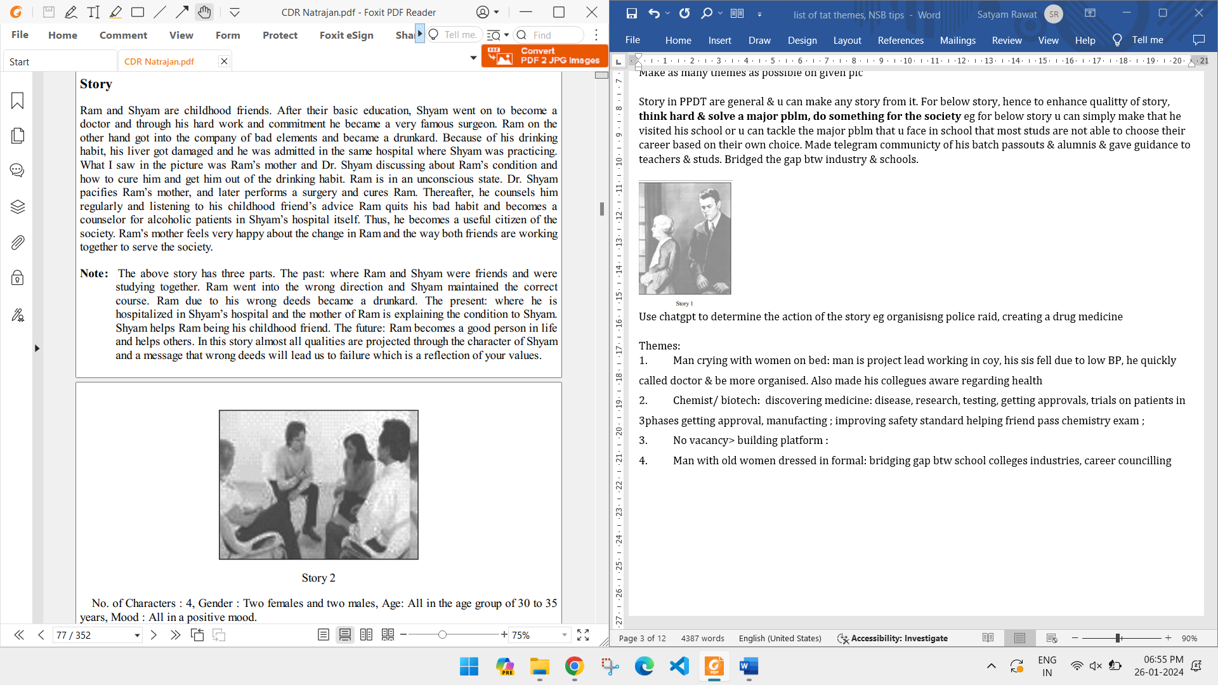

Use chatgpt to determine the action of the story eg organisisng police raid, creating a drug medicine

**#Scene of Factory or Workshop**Modification of Factory, safety, wages  
Quick Order Delivery  
New Invention  
New design  
  
**#Scene of Office Meeting/ Phone Calls**Board of director: coy launching a new software  
Presenting new idea  
Inventions  
New techniques  
New change education system  
Planning attack  
  
**# Scene of Fight/Running/Knife in hand/ Pistol in hand/Catching the Throat**how hero resolved the fight  
  
**#Scene of Defence Forces /Army Soldiers**Patrolling  
Planning  
Attack  
Destroying enemy target  
Destroying Amn dump  
Getting information of enemy  
  
**#Scene of Vehicle Car/ Bike**Car/Bike rally regarding awareness

Integrating IOT device into vehicle for safety  
New design of an engine  
Pollution free vehicles  
Less competition  
Multi fuel design  
  
**#Group of Girls/women**Vocational training center  
Cottage industries  
Handicraft industry  
Health/hygiene training  
SSB selection training  
Modeling  
Dramatics  
Folk dancing  
Family Planning  
  
**#Scene of Boat/River/lake**supervisor organising the competition( if he is visible)

Boating competition  
New design of boat  
Racing  
Rafting  
  
**#Scene of Bridge**Repair of bridge  
New design  
Widening of bridge  
Bridge inauguration  
  
**#Scene of Mountains**Mineral/Oil discovery  
Plantation/forestation  
Tourism/archeological  
Hiking, skiing, study of historical structure  
Water/river  
Pollution  
Creating lake  
Reservoirs  
Tourist resort  
Boating  
Flood control  
Digging  
Navigation/waterway  
  
**#Land**New technology of agriculture  
Drip irrigation  
Digging canal  
Creation Reservoir for water  
Plantation  
Windmill  
  
**#People/Villager**Cottage industries  
Small scale industries  
Handicraft Industries  
Agricultural Industries  
Teaching new agricultural Method  
Education/Family planning/Child Marriage menace  
  
**#Road/traffic/accident**Widen road  
One- way traffic  
Bus facilities  
Street- lights  
Encroachment removal  
Zebra crossing  
Traffic lights  
Evacuation of hospital  
  
**#Boys scouts/cycle/car**NSS Camp  
Flood relief  
Cycle rally  
Car rally  
Picnic  
Jogging  
Peace march  
Blood donation  
Rescue operation  
  
**#Sitting in Office**  
Planning  
Research  
Relief operations i.e. flood, earthquake etc.

what led to the situation?

What is happening in the story?

What is the outcome ?

**section> TAT Themes:**

1. No vacancy> building platform :
2. Man with old women dressed in formal: bridging gap btw school colleges industries, career councilling
3. A group of men, women discussing : project lead briefing his team mbr about new project for wissen tech.
4. Child sad : insomnia went to doc, made routine to focus on studies
5. **Swimming: learning swimming for inter dept** swimming competition> enrol in swimming classes> mastered basics, learnt strokes> started running for building stamina & endurace> did cardio workout> practised in local competitions of stadium> soiught feedback & guidance> participated in college swimming ;
6. **Accident:** assess the situation stop oncoming traffic & bring injured to roadside> cover his bleeding> ask ppl & rush him to hospital > inform police> inform family> give statement> return home
7. Man crying with women on bed: man is project lead working in coy, his sis fell due to low BP, he quickly called doctor & be more organised. Also made his collegues aware regarding health
8. Chemist/ biotech: discovering medicine: disease, research, testing, getting approvals, trials on patients in 3phases getting approval, manufacting ; improving standards of chemistry lab ; helping friend pass chemistry exam ;
9. Ppl with knife: (NOTE: this cant be doctor coz they wear face masks); guy was travelling in train, saw few ppl attempting stealing luggage
10. Ppl Farming but one lady with book: poor family, came across scholarship exam, appeared for coaching, joined agriculture university, learnt about new techniques, published research paper, drip irrigation, composting,etc applied her knowledge to her father’s field.
11. Parents waiving off child at railway station: dropping son for new city travelling doing job there; cleaning station by station master
12. Hostpital scene: blood donation, insomnia
13. 3 middle age ppl discussion, women in saree: married friend has just shifted, helping him get a new flat in his city
14. Boy playing with toy, photo on side, mother in saree: bring additional char from outsid , make story of elder brother in 3rd year helping his brother succeed in joining his interest. He used autocad to help his brother prepare individual obstacle. Helped him learn freelancing to make indpdt
15. running : team lead motivating his team to run on sundays to build health on upcoming 7april. quickly completing targets. Took poll to determine team thought. Also shared plan with other team
16. man in village with 2 lady carrying wood: boy visiting village for research paper, wrote research his plan was incorporated by startups. Story2 :research paper on ujjwala, issues they are facing. Steps: choose research topic> literature survey> conduct research> prepared manuscript: title, abstract, intro, methodology, took guidance from other research papers from his company> selected a conference & submitted> peer review , accept & publish
17. wherever there is discussion: upcoming kindle pad launch, startup idea discussion, organising some event eg blood donation, aawareness drive, flood preparedness, college planning hackathon, cricket tournament, etc
18. suggest a soln in the end for eg smuggling : Following the success, Ravi submitted a report suggesting increased surveillance using drones and better coordination with intelligence units
19. army/ men with uniform: planning anti militant attack: info from locals, create simulations, prepare escape route, use drones, assign roles to team, medical backup, evacuate civilians. Catch militants off guard, complete mission without civilian casualty
20. scaling mountain peak: plan route, study weather, acclimatization, drills, first aid , communication, food mngt, dizziness, temporary camp
21. pic16 ssbcrack: crowded haridawr view: DM overseeing kumbh mela: health , police, water, sanitation, stampeded, CCTV, police booths, Patrolling. On the day avoided stampede, crowd estimation, design possible routes
22. pic17: developing sensor based prosthetics
23. pic18: organizing reunion with friends
24. pic19:

**Section> Other ssb**

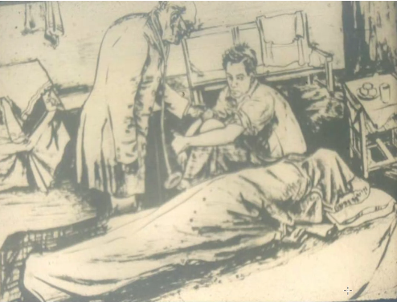death due to natural cause, boy tried to save but couldn’t, helped to find the body

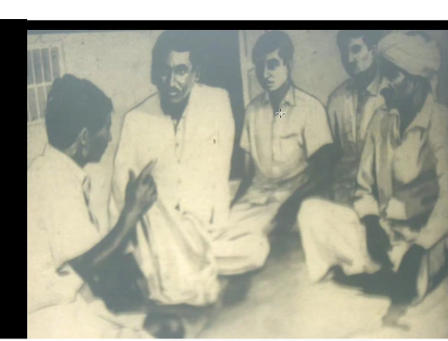BDO, door 2 door checking voter list,

farming, agriculture, govt schemes,

awaring ppl for elections, upcoming primary healthcare center in village.

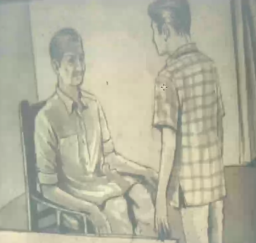Convincing parents

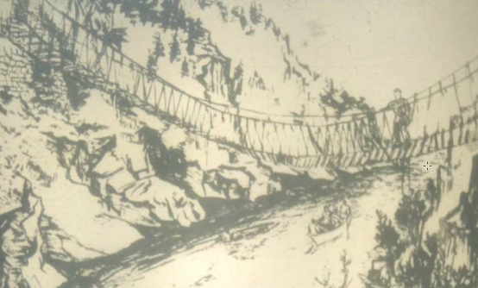ff

**section> prev ssb**

06.12 9:08 AM  
Tat pics nsb vizag  
1 He is a theif and we catch him (seriously dressed man and we following him)  
2 Boating in thunder storm (A boat with thunder and lightning infront of us )  
3. telling villagers importance of graduation (A rural boy with parents)   
4.( Fisherman rescuing drowning man)  
5 (some people doing Mountain climbing in snow)  
6 participating in college elections (some masses carrying banners)   
7 (we are on a single boat and rowing)  
8 Spending holidays in beach (A man with a lady)  
9  
10  
11 Flooded area and we are rescuing them  
12

**Section> MY life Relating life with TAT, WAT , SRT**

2020.11.03 4:27 PM

Discovery, nat geo, you have been warned, street genius, do or die, brain gamesquiz, debate, speaking skills, kavyanjali, exercise , stretching, discipline Captain, responsibility, running, exhibition, organising event, sports day, teachers day, learn from failure, education, sharing experience, quora, reading books of geo, history, political science   
  
  
Tat   
1.Dronacharya orchid fight with pol and guard  
2.Going to school storm comes marsjeet challenge is weather marksgeet problem his ability to tackle the situation   
3.Notice about a special quiz ,paper enrol. In that   
4.Salesman se- students of an organization sellnng thier product in the immense heat of Kashipur, loo a friend faints  
5.Interview -  
 1teachers discussing result and disc captain minding class  
 2 briefing for inter Army quiz  
3. Briefing of responsibility of upcoming inspection  
6.Giving nda process of going to Dehradun making friends going with them  
7. Eng teacher abhi organising debate for inter Army team   
8 teaching younger sister to crack iitjee  
9 A person catches COVID 19 before exam recovers and works hard to study.

2020.09.21 4:40 PM  
Wat words  
School removes hesitation in interacting with opposite sex .  
School life brings lot of opportunities and gives numerous memories   
Good students remain away from abusive words  
Good students remain from offensive word like duck   
Simplicity and no hesitation helps to make friends easily   
Love is all about respect   
Seniors don't bully those who respect them  
Seniors like juniors who respect them  
Hunger - smell of books arises hunger for reading   
Finish - finishing one task encourages for another

**section> SSB jalandhar TAT**

1. parents worried crying, elder pointing to father: failed IITJEE, worked hard to get good placement
2. man hand held from behind by another: drunk person mistook hero, hero assessed, helped him recover, talked to him next day
3. broken bridge, boys repairing : creating temporary crozzing, informing Municiplaity & getting repaired
4. 3 men in military attire: with father visiting army trainning area(messed up here)
5. man infront of mike: kavyanjali offline 1st time after covid
6. 4 ppl crossing a bridge: chetna vinnovate meet
7. Hand on telephone: asking for OTP from PSK office
8. Man outside office: getting documents corrected from friend back at college coz we are working outside
9. Man running with purse, 1policeman chasing : explaining how policeman caught him, later helped him get job
10. Man sitting on stairs with face down: I saw fat on his hands, stomach & made story to reduce it
11. Teacher with senior student in class: 4th year guiding 1st year for engineering course
12. 12th story: coding to get intern & package despite being from Tier3

SSB jalandhar interview : <https://www.youtube.com/watch?v=CUri07ohSok&ab_channel=DefenceRoger>

U should practice noting time for ur ans in interview. In 40min he has to ask 40q. if u r slow, u will only ans 30q & miss those10 points.

Also interviewer loses observation skill with time & candidate loses his focus. Don’t waste time behind telling jokes, etc.

Give to the point ans else ur EI is marked -ve

Drop year is not bad but IO wants u to know what is ur hardwork

12th story: life experience for blood camp

afpa

12th story : dream

GD TIPS:

What is more important concern for India: education, unemployment, safety for women, health, poverty?

**Education**

1. **Foundation for development:** Education is the bedrock of a nation's progress. It empowers individuals, fostering critical thinking, problem-solving skills, and innovation.
2. **Economic growth engine:** A skilled and educated workforce drives economic growth. India's demographic dividend can be harnessed only through quality education.
3. **Social mobility:** Education breaks down societal barriers and provides opportunities for upward mobility, reducing inequality.
4. **Health and well-being:** Educated individuals make informed choices about health, leading to better health outcomes.
5. **Reduced crime and poverty:** Education is linked to lower crime rates and poverty levels.
6. **Global competitiveness:** A well-educated population is crucial for India to compete in the global economy.
7. **Democratic participation:** Educated citizens are more likely to participate actively in democratic processes.
8. **Gender equality:** Education empowers women, leading to gender equality and women's empowerment.
9. **Scientific and technological advancement:** Education fosters innovation and technological breakthroughs.
10. **Cultural preservation:** Education helps preserve cultural heritage and values.

**Unemployment**

1. **Economic stagnation:** High unemployment rates stifle economic growth and reduce national income.
2. **Social unrest:** Joblessness can lead to social unrest, crime, and migration.
3. **Poverty and inequality:** Unemployment exacerbates poverty and income inequality.
4. **Brain drain:** Highly skilled individuals may migrate to countries with better job opportunities.
5. **Reduced tax revenue:** Unemployment reduces government revenue, limiting public spending on essential services.
6. **Mental health issues:** Joblessness can lead to stress, anxiety, and depression.
7. **Family instability:** Unemployment can strain family relationships and lead to domestic violence.
8. **Loss of human capital:** A significant portion of the workforce remains underutilized.
9. **Reduced consumer spending:** Unemployment lowers consumer demand, impacting businesses and the economy.
10. **Political instability:** High unemployment can destabilize governments and lead to political unrest.

**Safety for Women**

1. **Human rights violation:** Violence against women is a gross violation of human rights.
2. **Economic impact:** Violence against women hinders economic growth and development.
3. **Social and psychological trauma:** Victims of violence suffer from severe physical and psychological trauma.
4. **Loss of productivity:** Violence against women reduces women's participation in the workforce.
5. **Negative impact on children:** Children exposed to domestic violence are more likely to experience emotional and behavioral problems.
6. **Stigma and discrimination:** Victims of violence often face social stigma and discrimination.
7. **Undermining gender equality:** Violence against women perpetuates gender inequality and limits women's empowerment.
8. **Negative image of the country:** Violence against women tarnishes the image of India on the global stage.
9. **Public health crisis:** Violence against women is a major public health issue.
10. **Moral imperative:** Protecting women and girls is a moral obligation.

**Health**

1. **Human capital development:** Good health is essential for human capital development and productivity.
2. **Economic growth:** A healthy population contributes to economic growth.
3. **Reduced poverty:** Ill health can trap individuals and families in poverty.
4. **Social stability:** Poor health can lead to social unrest and instability.
5. **National security:** A healthy population is crucial for national security.
6. **Global competitiveness:** A healthy workforce is essential for global competitiveness.
7. **Reduced inequality:** Access to healthcare can reduce health disparities and inequality.
8. **Quality of life:** Good health improves the quality of life for individuals and families.
9. **Sustainable development:** Health is a key component of sustainable development.
10. **Moral imperative:** Providing healthcare is a moral obligation.

**Poverty**

1. **Human suffering:** Poverty leads to extreme deprivation, hunger, and malnutrition.
2. **Social and economic inequality:** Poverty exacerbates social and economic inequality.
3. **Reduced human capital:** Poverty limits access to education and healthcare, hindering human capital development.
4. **Environmental degradation:** Poverty often leads to environmental degradation and resource depletion.
5. **Social unrest:** Poverty can lead to social unrest, crime, and violence.
6. **Reduced tax revenue:** Poverty reduces government revenue, limiting public spending.
7. **Political instability:** Poverty can destabilize governments and lead to political unrest.
8. **Child labor:** Poverty forces children to work instead of attending school.
9. **Human trafficking:** Poverty makes individuals vulnerable to human trafficking.
10. **Moral imperative:** Alleviating poverty is a moral obligation

section> TAT actors Roles & responsibilities:

### 1. ****Municipal Corporation Officer****

**Title examples:** Commissioner, Executive Officer, Sanitation Officer  
**Powers:**

* **Urban governance:** Manages civic amenities like water supply, waste disposal, road maintenance, street lighting, etc.
* **Sanitation and Health:** Can impose penalties for unhygienic practices and close establishments violating public health norms.
* **Construction regulation:** Issues building permits and can demolish illegal constructions.
* **Revenue collection:** Oversees property tax, water charges, and other municipal revenues.
* **Disaster management:** Coordinates relief during floods, fire, or urban disasters.

### 2. ****Traffic In-Charge****

**Title examples:** Traffic Police Inspector, DCP (Traffic), RTO Officer  
**Powers:**

* **Traffic regulation:** Controls and regulates traffic flow in urban areas.
* **Issuing fines:** Can issue challans for violations like overspeeding, drunk driving, or signal jumping.
* **Vehicle seizure:** Can seize vehicles for lack of documentation or major violations.
* **Road safety:** Implements traffic safety measures and campaigns.
* **Special powers during VIP movement or emergencies.**

### 3. ****Sub-Divisional Magistrate (SDM)****

**Powers:**

* **Executive Magistrate:** Maintains law and order; can impose **Section 144** (curfew) in public interest.
* **Revenue authority:** Looks after land revenue, property disputes, mutation, and land acquisition.
* **Disaster relief:** Heads relief operations in case of natural calamities within the subdivision.
* **Licensing authority:** Issues arms licenses, marriage certificates, and other legal permits.
* **Election officer:** Supervises elections within their jurisdiction.

### 4. ****School Principal****

**Powers:**

* **Academic supervision:** Leads the curriculum, pedagogy, and performance of staff and students.
* **Administrative authority:** Hires staff, allocates duties, and monitors discipline.
* **Disciplinary actions:** Can suspend students or take action against staff for misconduct.
* **Budget control:** Approves expenses related to school functioning.
* **Liaison role:** Acts as a link between school management, government bodies, and parents.

### 5. ****District Collector / District Magistrate (DM)****

**Powers:**

* **Administrative head:** Topmost officer in a district; manages all district-level government operations.
* **Law and order:** Head of police in the district; can impose curfew, issue preventive detention orders.
* **Revenue collection:** Oversees land revenue, tax collection, and land records.
* **Development head:** Implements central/state schemes and district development programs.
* **Disaster management:** Coordinates emergency responses and relief distribution.

### 6. ****Police Inspector / Station House Officer (SHO)****

**Powers:**

* **Criminal jurisdiction:** Can register FIRs, investigate crimes, arrest suspects, and supervise investigations.
* **Law enforcement:** Maintains peace and order in the jurisdiction.
* **Preventive actions:** Can impose night patrolling, surveillance, and curfew in volatile areas.
* **Special laws:** Enforces traffic, narcotics, arms, and other criminal laws.
* **Custodial authority:** Manages the police station and detains accused persons as per law.

### 7. ****Judge (District or Sessions Court)****

**Powers:**

* **Judicial authority:** Has the power to conduct trials, pass judgments, and interpret laws.
* **Punitive power:** Can sentence individuals to jail, impose fines, or grant bail.
* **Civil & criminal jurisdiction:** Handles property disputes, divorce, criminal cases, etc.
* **Supervisory role:** Monitors lower courts in the district.
* **Special Acts:** Can try cases under anti-corruption, narcotics, terrorism laws (if designated).

### 8. ****Block Development Officer (BDO)****

**Powers:**

* **Rural administration:** Coordinates development programs like MNREGA, Swachh Bharat, PMAY.
* **Panchayat supervision:** Guides village panchayats and gram sabhas in governance.
* **Fund allocation:** Disburses government grants for rural schemes.
* **Monitoring:** Evaluates execution of schemes, roads, health centers, and education.
* **Law & Order support:** Assists in maintaining peace during elections or disputes in villages.

### 9. ****Tehsildar / Revenue Officer****

**Powers:**

* **Land record authority:** Updates land records, mutations, and property documentation.
* **Tax collection:** Collects land revenue, irrigation dues, and other local taxes.
* **Magisterial powers:** Can hold inquiries, settle land disputes, and even issue arrest warrants in some cases.
* **Evictions:** Can carry out eviction drives on government land or encroachments.
* **Disaster relief:** Assists SDM in local level disaster response.

### 10. ****Forest Officer (Range Officer / DFO)****

**Powers:**

* **Forest protection:** Prevents illegal logging, poaching, and encroachment on forest land.
* **Environmental regulation:** Implements environmental laws, biodiversity protection, and wildlife acts.
* **Magisterial powers:** Can seize vehicles, tools, and arrest offenders involved in forest crimes.
* **Permit authority:** Issues permits for grazing, minor forest produce, or research.
* **Tribal liaison:** Works with tribal communities for sustainable forest management.

### 11. ****Public Health Officer (PHO)****

**Sector:** Health Department / Municipal Bodies  
**Powers:**

* Oversees public health initiatives like sanitation drives, disease control, and vaccination.
* Can issue closure notices to clinics or eateries violating health norms.
* Supervises health inspectors, dispensaries, and urban health programs.
* Coordinates during outbreaks (e.g., dengue, cholera, COVID-19).

### 12. ****Assistant Conservator of Forests (ACF)****

**Sector:** Forest / Environment  
**Powers:**

* Assists DFO in wildlife protection and forest administration.
* Conducts anti-encroachment and forest fire control operations.
* Can arrest violators under forest and wildlife protection laws.
* In charge of a sub-division within a forest division.

### 13. ****Assistant Commandant (CAPF – CRPF/BSF/ITBP/etc.)****

**Sector:** Paramilitary / Home Ministry  
**Powers:**

* Commands a company (100–150 troops) in Central Armed Police Forces.
* Enforces law in disturbed areas, handles border security, riots, insurgency.
* Has the authority to make arrests and conduct operations under special acts.
* Participates in election security and disaster relief.

### 14. ****Regional Transport Officer (RTO)****

**Sector:** Transport Department  
**Powers:**

* Issues driving licenses, vehicle registrations, and fitness certificates.
* Conducts inspections of commercial vehicles.
* Can fine or seize vehicles violating transport laws.
* Implements motor vehicle and emission norms.

### 15. ****Sub Registrar (Revenue Department)****

**Sector:** Revenue / Registration  
**Powers:**

* Registers property transactions, marriages, wills, and other legal documents.
* Collects stamp duty and registration fees.
* Prevents fraudulent registrations and checks legality of documents.
* Maintains permanent land/property records.

### 16. ****Deputy Collector****

**Sector:** State Administration  
**Powers:**

* Handles land acquisition, compensation distribution, and electoral duties.
* Acts as an executive magistrate for certain cases.
* Coordinates between tehsils and district headquarters.
* May be assigned law-and-order, development, or protocol responsibilities.

### 17. ****Assistant Director (Sports / Youth Affairs)****

**Sector:** Sports Ministry / State Youth Departments  
**Powers:**

* Develops sports programs in schools, colleges, and rural areas.
* Manages stadiums, training camps, and athlete sponsorships.
* Recruits coaches and coordinates sports events.
* Liaises with sports federations and NGOs.

### 18. ****Food & Civil Supplies Officer****

**Sector:** Food Department  
**Powers:**

* Supervises ration distribution, public distribution system (PDS).
* Conducts raids on hoarders and black-marketers.
* Ensures fair price shops function properly.
* Coordinates grain procurement and storage.

### 19. ****Scientific Officer (Forensics / Atomic Energy / Environment)****

**Sector:** Various Scientific Departments  
**Powers:**

* Investigates crime scenes and provides forensic reports (in police departments).
* Works on sensitive scientific research or policy.
* Can give expert witness testimony in courts.
* Holds technical authority in labs and research facilities.

### 20. ****Tourism Officer****

**Sector:** Tourism Department  
**Powers:**

* Promotes tourism infrastructure, manages heritage sites and events.
* Grants licenses to tour operators and guides.
* Coordinates with police for tourist safety.
* Plans campaigns and works with hospitality industry stakeholders.

### 21. ****Superintendent of Police (SP)****

**Sector:** Police / Home Department  
**Powers:**

* Head of district police; maintains law and order.
* Supervises all police stations in the district.
* Approves major investigations, arrests, and security arrangements.
* Coordinates with intelligence and other law enforcement bodies.

### 22. ****Agriculture Officer / District Agriculture Officer****

**Sector:** Agriculture Department  
**Powers:**

* Implements government schemes for farmers (e.g., PM-KISAN, fertilizer subsidies).
* Advises on crop planning, pest control, and irrigation.
* Monitors soil health and provides certification.
* Has authority over local Krishi Vigyan Kendras (KVKs) and agri-related staff.

### 23. ****Divisional Forest Officer (DFO)****

**Sector:** Forest / Environment  
**Powers:**

* Controls an entire forest division.
* Authorizes forest patrol, anti-poaching operations, and land surveys.
* Can seize illegal forest produce and arrest offenders.
* Works on afforestation and wildlife conservation programs.

### 24. ****Assistant Engineer (AE) / Executive Engineer (EXEN)****

**Sector:** Public Works Department, Irrigation, Electricity  
**Powers:**

* Oversees infrastructure projects like roads, bridges, canals.
* Approves public tenders and ensures contractor compliance.
* Supervises junior engineers and site operations.
* Authorizes repairs and inspection reports.

### 25. ****Swimming Pool Manager / Lifeguard Officer****

**Sector:** Sports Authority, Municipal Corporation, Private Sector  
**Powers:**

* Ensures safety, hygiene, and operation of public/private swimming pools.
* Supervises lifeguards and training schedules.
* Can close pool due to health violations or safety risks.
* Trains swimmers and enforces pool regulations.

### 26. ****Assistant Commissioner (AC) / Additional Collector****

**Sector:** Revenue / General Administration  
**Powers:**

* Acts as deputy to the District Collector.
* Can preside over revenue cases, land disputes, and development projects.
* Supervises block- and tehsil-level officers.
* Represents collectorate in meetings and emergencies.

### 27. ****Customs Officer****

**Sector:** Finance / Revenue / CBIC  
**Powers:**

* Inspects goods at ports, airports, and borders.
* Can seize illegal imports/exports and arrest offenders.
* Imposes customs duty, anti-dumping duty, and other taxes.
* Works with DRI and intelligence units for smuggling control.

### 28. ****Food Safety Officer (FSO)****

**Sector:** Health / Food & Drug Administration  
**Powers:**

* Inspects food establishments, street vendors, and processing units.
* Can seal unsafe food outlets and issue notices.
* Collects food samples and sends them for lab testing.
* Enforces the Food Safety and Standards Act.

### 29. ****Assistant Commissioner of Income Tax (ACIT)****

**Sector:** Income Tax Department  
**Powers:**

* Handles tax assessments, audits, and enforcement.
* Can conduct raids, surveys, and issue notices under the IT Act.
* Imposes penalties for tax evasion.
* Works under CBDT guidelines for revenue generation.

### 30. ****Chief Fire Officer / Fire Station Officer****

**Sector:** Disaster Management / Municipal Fire Services  
**Powers:**

* Leads fire-fighting teams in emergencies.
* Conducts fire audits of buildings and factories.
* Can order evacuation and seal buildings for fire code violations.
* Trains personnel and oversees rescue operations.

Section> imp govt schemes

### ****Pradhan Mantri Awas Yojana (PMAY)****

* **Purpose:** Affordable housing for all.
* **Benefits:** Subsidized home loans for economically weaker sections (urban & rural areas).

## ☀️ ****Pradhan Mantri Surya Ghar Muft Bijli Yojana****

* **Launched**: February 29, 2024 (expanded through 2025)
* **Features**: Rooftop solar installations, 300 free units/month for 1 crore households, 40% subsidy + concessional loans [timesofindia.indiatimes.com+4en.wikipedia.org+4dailyissues3.com+4](https://en.wikipedia.org/wiki/Pradhan_Mantri_Surya_Ghar_Muft_Bijli_Yojana?utm_source=chatgpt.com).
* **Impact**: Lowers electricity bills, promotes renewable energy adoption among common households.

### 🧒 ****14. Integrated Child Development Services (ICDS)****

* **Purpose:** Nutrition and early education.
* **Benefits:** Food, health check-ups, and pre-school education via Anganwadi centers.

### 💡 ****8. Saubhagya Yojana****

* **Purpose:** Electricity for all households.
* **Benefits:** Free electricity connection to BPL households.

### 💧 ****9. Jal Jeevan Mission****

* **Purpose:** Tap water to every rural household.
* **Benefits:** Piped drinking water supply in villages.

**Section> Organizing any tournament requires :**

**planning organizing & execution:**

objective

budget

venue & logistics

team & roles

rules

safety

### 🏃 1. ****Race Competition (e.g., 100m dash, marathon)****

**Planning Phase:**

* **Define Race Type:** Sprint, middle-distance, long-distance, or fun run.
* **Select Date and Venue:** Track stadium, road circuit, or park.
* **Permissions:** Get approvals from local authorities and traffic police (if road race).
* **Budget:** Include cost of bibs, timing system, medical team, refreshments, etc.

**Organizing Phase:**

* **Registration:** Online/offline with participant details.
* **Logistics:**
  + Mark start and finish lines.
  + Arrange timing systems (manual or chip-based).
  + Hire first aid and hydration stations.
* **Volunteers:** To manage crowd, checkpoints, emergency, etc.

**Execution Phase:**

* Conduct a briefing, provide race kits, and ensure safety.
* Start races on time.
* Timekeepers/judges to monitor performance.
* Declare results and distribute medals/trophies.

### ⚽ 2. ****Football Tournament****

**Planning Phase:**

* **Tournament Type:** Knockout, league, or round-robin.
* **Team Invitations:** Decide on the number of teams (even number preferred).
* **Venue:** Football ground(s) with goalposts and markings.
* **Equipment:** Balls, jerseys, cones, whistles, nets.

**Organizing Phase:**

* **Fixtures & Rules:** Create a match schedule and clearly define rules.
* **Referees:** Hire certified officials for fair play.
* **Medical & Security:** On-standby for injuries or crowd control.
* **Marketing:** Posters, social media for promotion.

**Execution Phase:**

* Begin matches on time.
* Keep scores and maintain a leaderboard.
* Manage crowd and player discipline.
* Award ceremony at the end.

### 👨‍💻 3. ****Hackathon****

**Planning Phase:**

* **Theme/Problem Statements:** Decide whether it’s open innovation or problem-specific.
* **Duration:** Typically 24–48 hours.
* **Venue:** On-site (labs) or online platforms.
* **Sponsors & Partners:** Tech companies, APIs, mentors.

**Organizing Phase:**

* **Registration:** Online forms with team formation.
* **Infrastructure:** Wi-Fi, power supply, seating, access to software/tools.
* **Mentors & Judges:** Industry experts for guidance and evaluation.

**Execution Phase:**

* Kickoff with a keynote or briefing.
* Teams work on their ideas with mentor feedback.
* Final presentations or demos.
* Judges evaluate based on criteria (innovation, feasibility, impact).
* Announce winners and distribute prizes.

### 🗣️ 4. ****Debate Competition****

**Planning Phase:**

* **Format:** Oxford-style, Lincoln-Douglas, or panel debate.
* **Topic Selection:** Relevant, debatable, and age-appropriate.
* **Participants:** Individual or teams (2 or 3 per team).

**Organizing Phase:**

* **Judges:** Experts in communication, logic, or topic-related fields.
* **Time Management:** Set strict speaking time limits (e.g., 3–5 mins per speaker).
* **Venue Setup:** Podium, microphones, audience seating.

**Execution Phase:**

* Introduce the topic and rules.
* Allow teams to present their arguments and rebuttals.
* Judges take notes and score based on content, delivery, and rebuttal strength.
* Declare winners and give feedback.

### 🏊 5. ****Swimming Competition****

**Planning Phase:**

* **Event Types:** Freestyle, breaststroke, backstroke, butterfly, medley.
* **Age/Gender Categories:** Decide participant brackets.
* **Venue:** Pool that meets safety and competition standards.

**Organizing Phase:**

* **Lane Assignments:** Allocate lanes via heats or random draw.
* **Timers & Referees:** Appoint certified officials for each lane.
* **Safety:** Lifeguards, first aid kits, and emergency protocols.

**Execution Phase:**

* Conduct warm-ups and briefing.
* Start races with proper signaling.
* Judges time and monitor for false starts or disqualifications.
* Collate results and announce winners.

Section> Technical actions

**1> Launching a startup: MY theme : like Vinnovates’s umesh, create ur own SAAS company that sells softwares**

**in short: pblm → market research → plan → team**

### 🚀 1. ****Identify a Problem & Validate an Idea****

* Find a real-world problem worth solving.
* Talk to potential users/customers.
* Validate the idea with surveys, interviews, or MVP (Minimum Viable Product).

### 🧠 2. ****Do Market Research****

* Analyze your target audience.
* Study competitors and industry trends.
* Identify market gaps and define your **Unique Value Proposition (UVP)**.

### 🧾 3. ****Create a Business Plan****

* Define your mission, vision, and goals.
* Outline product/service, target market, revenue model, and cost structure.
* Include go-to-market strategy and funding needs.

### 👥 4. ****Build the Right Team****

* Find co-founders or early team members with complementary skills (tech, business, marketing).
* Clarify roles and responsibilities.
* Establish trust, equity, and legal structure (like founders’ agreement).

### 🛠️ 5. ****Develop the MVP (Minimum Viable Product)****

* Build a simple version of your product that solves the core problem.
* Focus on functionality, not perfection.
* Get early feedback and iterate.

### 📣 6. ****Launch & Get Early Users****

* Launch to a small target audience.
* Use digital marketing, community engagement, and outreach to attract early adopters.
* Track usage and user feedback.

### 💰 7. ****Secure Funding (if needed)****

* Bootstrap or raise seed funding from friends, family, or angel investors.
* Prepare a pitch deck.
* Explore incubators, grants, or venture capital if scalable.

### 📈 8. ****Scale & Optimize****

* Improve based on user feedback and data.
* Invest in marketing, operations, and hiring.
* Focus on growth while keeping an eye on sustainability.

**Ideas:**

A mobile app or service that helps car pooling , start from ur company , spread to others.

App farmers get weather updates, crop advice, and fair market prices.

App to platform to connect doctors with ppl

app for subscripton for daily essentials

Starting own cybercafe to teach programming to school students

women safety app with SOS alert & GPS tracking